2. FRICTION
TERMINOLOGIES IN FRICTION:  - NORMAL REACTION ($N$):  - FORCE IN DIRECTION OF POSSIBLE MOTION ($P$):  - COEFFICIENT OF FRICTION ($μ$):  Static Friction Coefficient ($μ_{s}$) Kinetic or Dynamic Friction Coefficient ($μ_{k}$)  - FRICTIONAL FORCE ($f$): $f=μN$ | 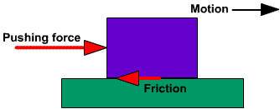

DYNAMICS ANALYSIS
KINEMATICS: Without considering Force | KINETICS: With considering force

LAW OF DRY FRICTION:  - The frictional force opposes the relative motion. (Coulomb’s Law Statement-I)  - The frictional force acts tangential to the contact surfaces. (Coulomb’s Law Statement-II)  - The total friction developed doesn’t depend upon the contact area.  - The maximum friction in static case, $f_{max}=μ_{s}N=Limiting Friction$  - Force required to sliding is frater than that is required to maintain sliding. $μ_{s}>μ_{k}$ | GRAPHICAL REPRESENTATION OF FRICTIONAL FORCE:  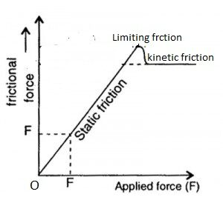
UNDERSTANDING THE FRICTIONAL FORCE:
If $P≤f_{max},$ $f=P$. | If $P>f_{max},$ $f=μ_{k}N=Constant and opposite to P$
Impending Condition: Body is about to move but block hasn’t started motion. $P=f_{max}$
Condition for Static Equilibrium: $μ_{s}N≤P or f≤μ_{s}N$
When to use the limiting frictional force ($f_{max}$):
- Limiting Friction  - Impending Condition | - Maximum Force for equilibrium  - Minimum force to start motion (Force just to start motion)

ANGLE OF FRICTION ($∅$):  $$R=\sqrt{N^{2}+f^{2}}$$ $$∅=\tan^{-1}{\frac{f}{N}}$$  At Limiting Friction, $∅=\tan^{-1}{μ_{s}}$  CONE OF FRICTION: Cone generated with cone angle $2∅$ is known as cone of friction. | 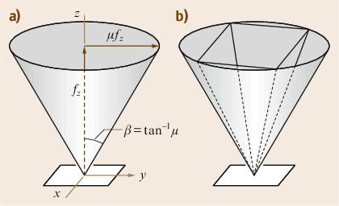 | 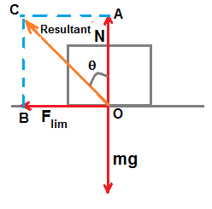
- Minimum force required to cause the motion in the block, $F_{min}=W \sin{θ}, Where θ=∅$
BELT FRICTION:  $$\frac{T_{1}}{T_{2}}=e^{μθ}$$ | $θ=$ Angle of contact,  $μ=$ Friction between belt and friction,  $T_{1}\& T_{2}=$ Tight side and slack side tension. | The side of belt which will try to create the motion or higher force is applied is the tight side.
- After deciding tight side and slack side we can decide the Force/ Tension is either minimum or maximum.
Sliding: Consider Equilibrium of forces.  Tipping: Consider Moment Equilibrium about tipping point.  For Inclined Block at $θ$ angle with self-weight,  $$θ<∅$$ $$θ=∅$$ $$θ>∅$$  Static Cond. Impending Cond. Motion  $$f=P$$ $$f_{max}=μ_{s}N$$ $$f_{max}=μ_{k}N$$  $∅=$ Angle of friction. | 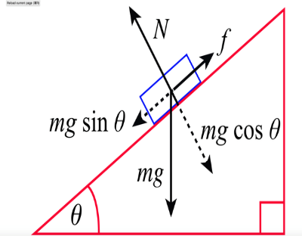 | 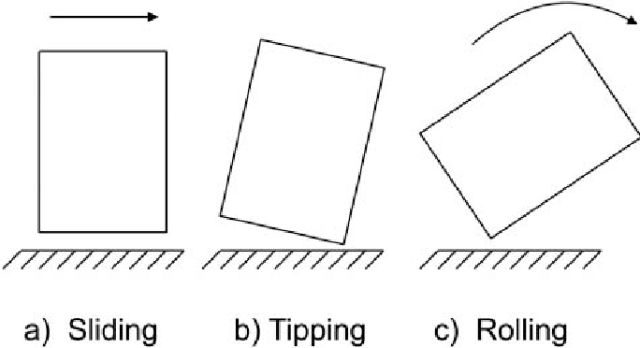
ANGLE OF REPOSE: It’s the angle at which block slides on any surface. E.g. For inclined surface AOR $=∅$
Min. and Max. force required to stop sliding the bock on inclined surface found by changing the direction of friction.
Both are smooth (Unstable) | Wall is rough & floor is smooth (Unstable) | Floor is rough & Wall is smooth (stable) | Floor is rough & Wall is rough (stable)
Pythagoras Theorem | $\sum{F}=0$ | $\sum{M_{@Rough Normal Reaction}}=0$
Stability of inclined ladder increases including angle of inclination Because $Restoring Couple=Turning Couple$.

